LECTURE 19

REMEDIES OF THE BUYER

Rachel Avery

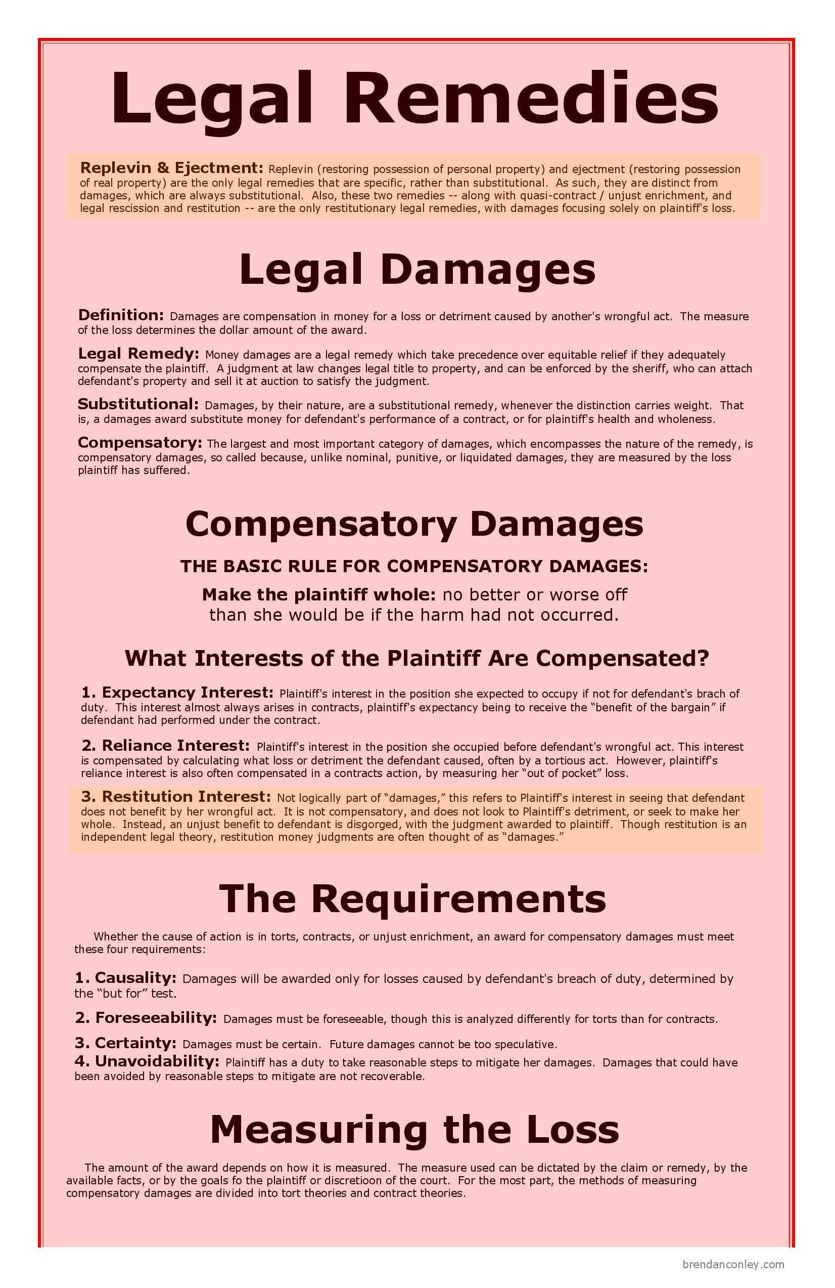
This Photo by Unknown Author is licensed under CC BY-SA-NC
This Photo by Unknown Author is licensed under CC BY-NC-ND

READING

Essential Reading:

- Twigg-Flesner and Canavan, Atiyah and Adams’ Sale of Goods pp. 417-466

- Fox et al, Sealy and Hooley’s, Commercial Law: Text, Cases, pp. 485-498

- McKendrick, Goode, Commercial Law, pp. 427-463

Further Reading:

- Apps, The Right to Cure Defective Performance [1994] LMCLQ 525

I. Sale of Goods Act 1979:
a. Damages
- Generally
- Non-delivery
- S.51, SGA 1979:
  - Reflects the first limb of the rule in Hadley v. Baxendale (see below)
  - Once it is established that the damages were not too remote, the measure of damages depends on whether there is an available market.
    - If available market: damages = market price – contract price
    - If no available market: process in s.51(2) SGA 1979 – heavily dependent on the purpose for which the goods were bought.
- Hadley v. Baxendale (1854) 9 Exch 341 test:
Damages for breach of contract include:
  - Those which arise naturally from the breach of contract OR
  - Those which may reasonably be said to have been in the contemplation of both parties at the time the contract was made.
- Late delivery
- Victoria Laundry v. Newman [1949] 2 KB 528
- Damages for breach of warranty
- s.53 SGA 1979
(v) Consequential Loss
- Godley v. Perry [1960] 1 All ER 36
- Parsons v. Uttley Ingham [1978] QB 791

b. Specific Performance
  - S.51 SGA 1979
  - Re Wait [1927] 1 Ch 606
  - Sky Petroleum v. VIP Petroleum [1974] 1 All ER 954
  - Société des Industries Métallurgiques S.A. v Bronx Engineering Co Ltd [1975] 1 Lloyd’s Rep 465

c. Rejection of the Goods
- When can B reject the goods?
(Note the qualifications in SGA 1979 : s.15A and s.11(2))
- What are the consequences of rejection?
- How?
- Meaning of ‘acceptance’
- s.35 SGA 1979, s.35:
(1) The buyer is deemed to have accepted the goods subject to subsection (2) below—
(a) when he intimates to the seller that he has accepted them, or
(b) when the goods have been delivered to him and he does any act in relation to them which is inconsistent with the ownership of the seller.
(2) Where goods are delivered to the buyer, and he has not previously examined them, he is not deemed to have accepted them under subsection (1) above until he has had a reasonable opportunity of examining them for the purpose—
(a) of ascertaining whether they are in conformity with the contract, and
(b) in the case of a contract for sale by sample, of comparing the bulk with the sample.
(3) Where the buyer deals as consumer ... the buyer cannot lose his right to rely on subsection (2) above by agreement, waiver or otherwise.
(4) The buyer is also deemed to have accepted the goods when after the lapse of a reasonable time he retains the goods without intimating to the seller that he has rejected them.
(5) The questions that are material in determining for the purposes of subsection (4) above whether a reasonable time has elapsed include whether the buyer has had a reasonable opportunity of examining the goods for the purpose mentioned in subsection (2) above.
(6) The buyer is not by virtue of this section deemed to have accepted the goods merely because—
(a) he asks for, or agrees to, their repair by or under an arrangement with the seller, or
(b) the goods are delivered to another under a sub-sale or other disposition.”
Case law on the meaning of ‘acceptance’:
  - Kwei Tek Chao v. British Traders and Shippers Ltd [1954] 2 QB 459
  - Armaghdown Motors v. Gray [1963] NZLR 5
  - Jones v. Gallagher [2004] EWCA Civ 10 (noted Lawson, (2004) 148 SJ 1134)
  - Bernstein v. Pamson Motors [1987] 2 All ER 220
  - Truk (UK) v. Tokmakidis [2000] 1 LL Rep 543
  - Clegg v. Anderson [2003] EWCA Civ 320
  - J H Ritchie Ltd v. Lloyd Ltd [2007] UKHL 9
- Partial rejection
- S.35A SGA 1979
- Instalment Contracts
- Maple Flock v. Universal Furniture Products [1934] 1 KB 148
- Munro v. Meyer [1930] 2 KB 312

II. Consumer Rights Act 2015:
The CRA introduces important changes in this area. It revokes the Sale and Supply of Goods to Consumers Regulations 2002 and also amends the Sale of Goods Act 1979, including:
- S. 35 (acceptance – not applicable to a contract to which chapter 2 of Part 1 CRA2015 applies, but see the provision made about such contracts in CRA 2015, s.21)
- s. 51 (damages for non-delivery – not applicable to a contract to which chapter 2 of Part 1 CRA 2015 applies, but see the provision made about such contracts in SGA s. 19),
- s. 52 (specific performance – not applicable to a contract to which chapter 2 of Part 1 CRA 2015 applies, but see the provision made about such contracts in SGA s. 19),
- s. 53 (remedy for breach of warranty – not applicable to a contract to which chapter 2 of Part 1 CRA 2015 applies, but see the provision made about such contracts in SGA s. 19)

CRA 2015, s 19: consumer's rights to enforce terms about goods
(1) In this section and sections 22 to 24 references to goods conforming to a contract are references to—
(a) the goods conforming to the terms described in sections 9, 10, 11, 13 and 14,
(b) the goods not failing to conform to the contract under section 15 or 16, and
(c) the goods conforming to requirements that are stated in the contract.
(2) But, for the purposes of this section and sections 22 to 24, a failure to conform as mentioned in subsection (1)(a) to (c) is not a failure to conform to the contract if it has its origin in materials supplied by the consumer.
(3) If the goods do not conform to the contract because of a breach of any of the terms described in sections 9, 10, 11, 13 and 14, or if they do not conform to the contract under section 16, the consumer's rights (and the provisions about them and when they are available) are—
(a) the short-term right to reject (sections 20 and 22);
(b) the right to repair or replacement (section 23); and
(c) the right to a price reduction or the final right to reject (sections 20 and 24).
(4) If the goods do not conform to the contract under section 15 or because of a breach of requirements that are stated in the contract, the consumer's rights (and the provisions about them and when they are available) are—
(a) the right to repair or replacement (section 23); and
(b) the right to a price reduction or the final right to reject (sections 20 and 24).
(5) If the trader is in breach of a term that section 12 requires to be treated as included in the contract, the consumer has the right to recover from the trader the amount of any costs incurred by the consumer as a result of the breach, up to the amount of the price paid or the value of other consideration given for the goods.
(6) If the trader is in breach of the term that section 17(1) (right to supply etc) requires to be treated as included in the contract, the consumer has a right to reject (see section 20 for provisions about that right and when it is available).
(7) Subsections (3) to (6) are subject to section 25 and subsections (3)(a) and (6) are subject to section 26.
(8) Section 28 makes provision about remedies for breach of a term about the time for delivery of goods.
(9) This Chapter does not prevent the consumer seeking other remedies—
(a) for a breach of a term that this Chapter requires to be treated as included in the contract,
(b) on the grounds that, under section 15 or 16, goods do not conform to the contract, or
(c) for a breach of a requirement stated in the contract.
(10) Those other remedies may be ones—
(a) in addition to a remedy referred to in subsections (3) to (6) (but not so as to recover twice for the same loss), or
(b) instead of such a remedy, or
(c) where no such remedy is provided for.
(11) Those other remedies include any of the following that is open to the consumer in the circumstances—
(a) claiming damages;
(b) seeking specific performance;
(c) seeking an order for specific implement;
(d) relying on the breach against a claim by the trader for the price;
(e) for breach of an express term, exercising a right to treat the contract as at an end.
(12) It is not open to the consumer to treat the contract as at an end for breach of a term that this Chapter requires to be treated as included in the contract, or on the grounds that, under section 15 or 16, goods do not conform to the contract, except as provided by subsections (3), (4) and (6).
(13) In this Part, treating a contract as at an end means treating it as repudiated.
(14) For the purposes of subsections (3)(b) and (c) and (4), goods which do not conform to the contract at any time within the period of six months beginning with the day on which the goods were delivered to the consumer must be taken not to have conformed to it on that day.
(15) Subsection (14) does not apply if—
(a) it is established that the goods did conform to the contract on that day, or
(b) its application is incompatible with the nature of the goods or with how they fail to conform to the contract.
See also:
Right of consumer to reject goods:
- CRA 2015, s. 20 (right to reject)
- CRA 2015, s. 21 (partial rejection of goods)
- CRA 2015, s. 22 (time limit for short-term right to reject)
- CRA 2015, s. 23 (right to repair or replacement)
- CRA 2015, s. 24 (right to price reduction or final right to reject)

Consumer rights with respect to delivery:
- CRA 2015, s. 25 (delivery of wrong quantity)
- CRA 2015, s. 26 (instalment deliveries)

Remedies with respect to digital content:
- CRA 2015, s. 42 (consumer’s rights to enforce terms about digital content)
- CRA 2015, s. 43 (right to repair or replacement)
- CRA 2015, s. 44 (right to price reduction)
- CRA 2015, s. 45 (right to refund)
- CRA 2015, s. 46 (remedy for damage to device or to other digital content)

